More on Redirection

1) Create X_file.txt file with some content.

2) Redirect the content of both out_file.txt and X_file.txt to a new file

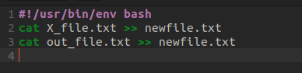

TERMINAL

